In 2021 Taproot upgrade introduced. This update allow us to attached some extra data (Image , file , video) with bitcoin stoshi.

-----------------------------------------------------------------------

Some Websites links for research

https://trustmachines.co/blog/brc-20-token-standard-vs-erc-20/#:~:text=To%20mint%20BRC%2D20%20tokens,%2C%20minting%2C%20and%20transferring%20functions.

https://blog.cryptostars.is/how-to-create-nft-on-bitcoin-using-ordinals-protocol-3344fa740336

https://docs.ordinals.com/

https://github.com/ordinals/ord/blob/master/bip.mediawiki#user-content-Reference_implementation

Theory of Ordinals
https://www.youtube.com/watch?v=rSS0O2KQpsI

Implementation of Ordinals:

https://www.youtube.com/watch?v=MC_haVa6N3I

Tutorial Part 1 :

https://www.youtube.com/watch?v=zXlvkOSVM9M

Tutorial Part 2:

https://www.youtube.com/watch?v=LXrUu8WOrHo

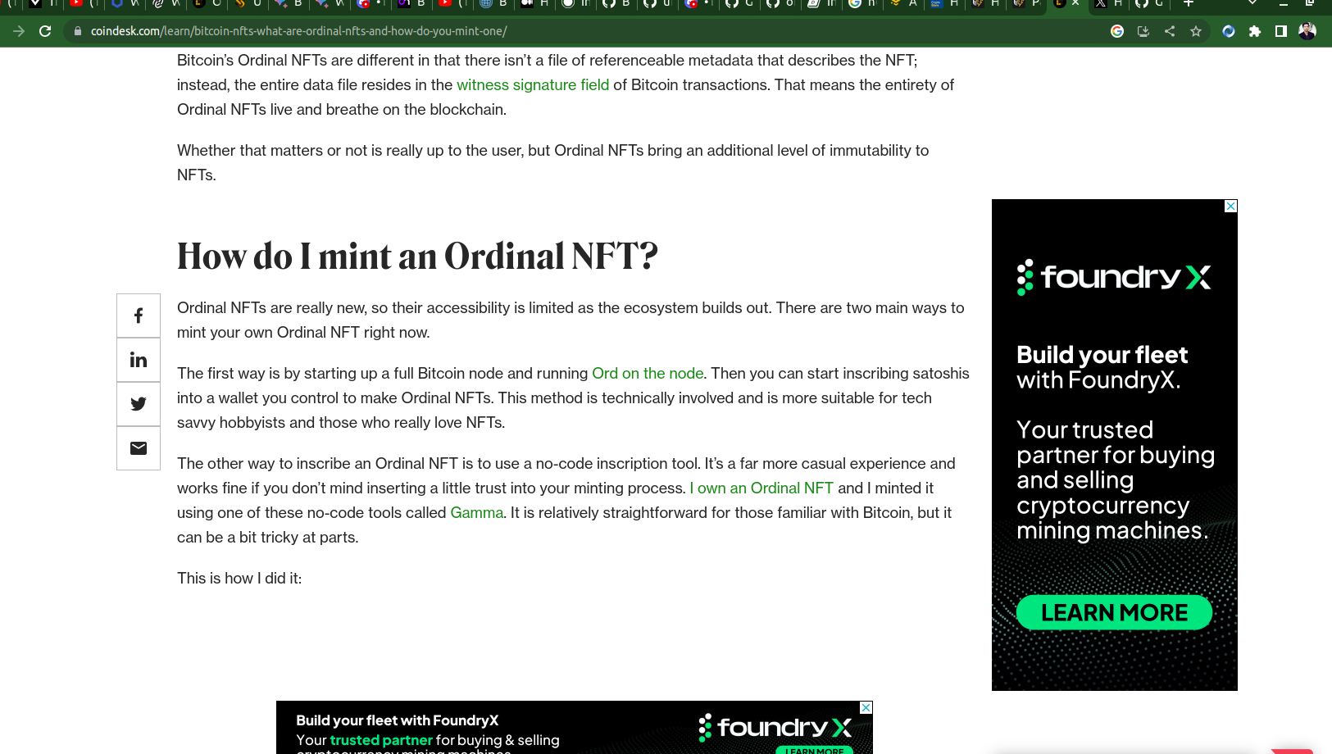

-----------------------------------------------------------------------
Create a bitcoin node in PC.

git clone https://github.com/bitcoin/bitcoin.git

Check the versions : git tag

git checkout v0.21.2

Install dependancies:

check Depentdancies : more doc/build-unix.md

$ sudo apt-get update
$ sudo apt-get install software-properties-common libssl-dev libevent-dev libboost-system-dev libboost-filesystem-dev libboost-chrono-dev libboost-test-dev libboost-thread-dev -y
$ sudo add-apt-repository ppa:bitcoin/bitcoin -y
$ sudo apt-get update
$ sudo apt-get install libdb4.8-dev libdb4.8++-dev -y

--------------------------------------------------------------------------------------------------

Complete steps:

install homebrew

install bitcoin ‘brew install bitcoin’

start bitcoin ‘brew services start bitcoin’

bitcoin-cli getblockcount

bitcoin-cli getblockchaininfo

cd ~/.bitcoin/
xdg-open ~/.bitcoin/

run the bitcoin in a saperate terminal (Window 1)

install cargo with rustup

install ord “cargo install ord”

ord --testnet server
ord server

load local block explorer: go to http://localhost

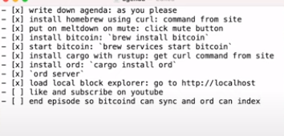

-----------------------------------------------------------------

BRC-20 important Aritcals:

- https://investorplace.com/2023/05/brc-20-tokens-the-investors-guide-to-cryptos-latest-craze

- https://medium.com/fourpillars/brc-20-revitalizing-the-bitcoin-network-e4e8df20f643

- https://ordiscan.com/docs/api#inscription-info

-----------------------------------------------------------------------------------

https://github.com/bitcoinschema/js-1sat-ord

https://github.com/neu-fi/awesome-ordinals#creator-tools

https://ordapi.xyz/

configuration bitcoind
https://bitcointalk.org/index.php?topic=5334666.0

$bitcoind –testnet -txindex -rpcuser=USERNAME -rpcpassword=PASSWORD

https://bitcoin.stackexchange.com/questions/24383/how-can-i-create-a-new-wallet-on-bitcoin-core/105225#105225

$ bitcoin-wallet -wallet=wallet.dat create

$ bitcoind -server -walletdir=/home/netsamir/.bitcoin/wallets/wallet.dat

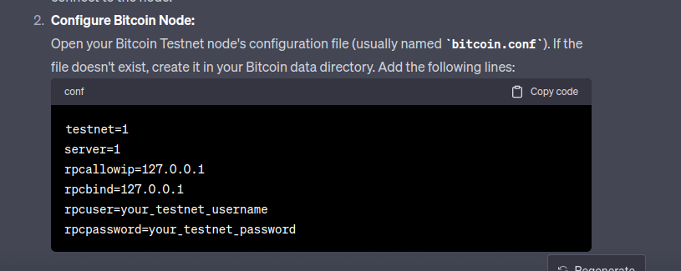
command for running the node with rpc and wallet

$ bitcoind --testnet -txindex -rpcuser=ahsan -rpcpassword=12345678 -walletdir=/home/vaival/.bitcoin/testnet3/wallets/wallet.dat

bitcoin.conf fiel
testnet=1
server=1
txindex=1
rpcallowip=127.0.0.1
rpcbind=127.0.0.1
rpcuser= "ahsan"
rpcpassword= "12345678"

